**SLIC SEGMENTATION**

1) This algorithm creates the super-pixel by dividing image of n pixels into k clusters of equal size as mentioned as the input parameter.

2) Then the centre of these clusters are adjusted according to the distance metric over different iterations.

3) Finally we get an image divided into k clusters after iterations are over.

**Algorithm**

**1) Initialise the clusters centres as the 5-D vector as (Lk, Ak, Bk, x, y) where Lk, Ak, Bk are L,A,B color space values respectively and x, y are the space coordinates of the cluster centres .These centres are initialised over a grid size of $√k/√n$.**

**2) Now, the image cluster centres are initialised at the point with lowest pixel gradient according to formula below.**



**3) Now, each pixel in image is assigned to the closest cluster centre in neighbourhood of 2S*2S.The closest cluster centre is calculated using following distance metric formulae:**

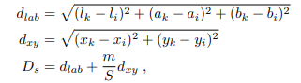



**Where m defines the proximity considered.**

**4) Cluster centres are changed according the average of the vectors associated with the concerned cluster.**

**5) Now calculate the new centres and residual error E till E<=threshold.**